Sprint -4

|  |  |
| --- | --- |
| Date | 10 November 2022 |
| Team ID | PNT2022TMID23850 |
| Project name | IOT based smart crop protection for agriculture |
| Mark | 20 |

Node js installation :

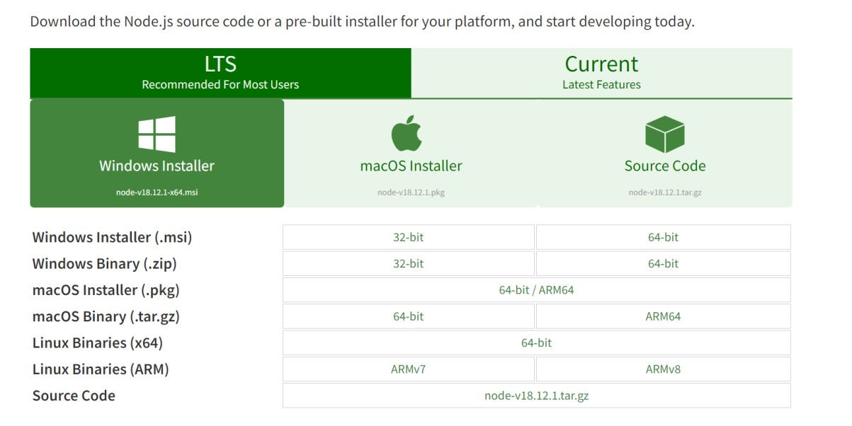

Configure command prompt for error check .open node-red from the generated link:

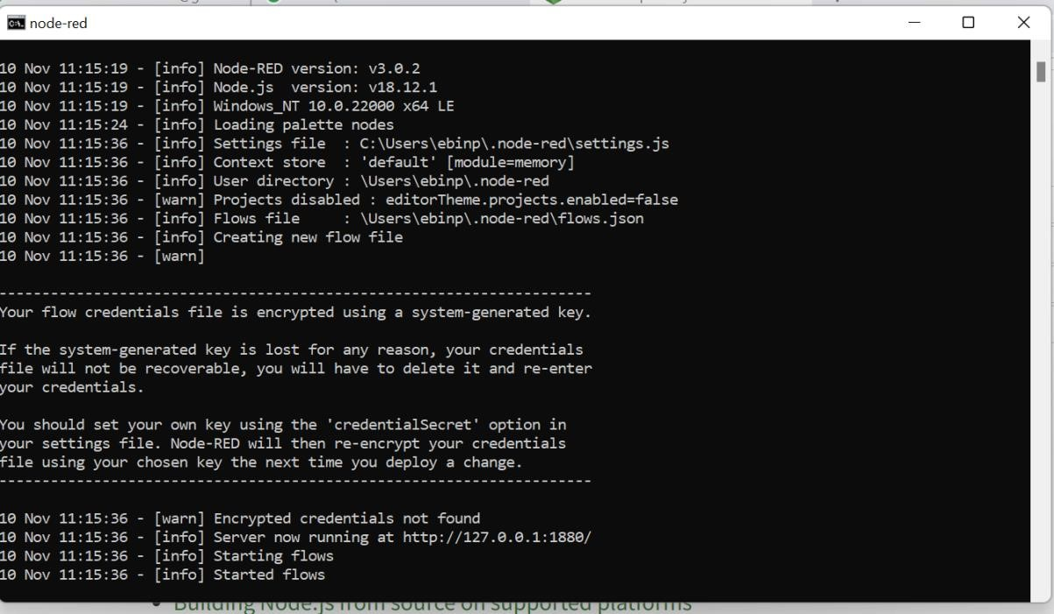

Connection IBM IOT in debug 1 and deploy:

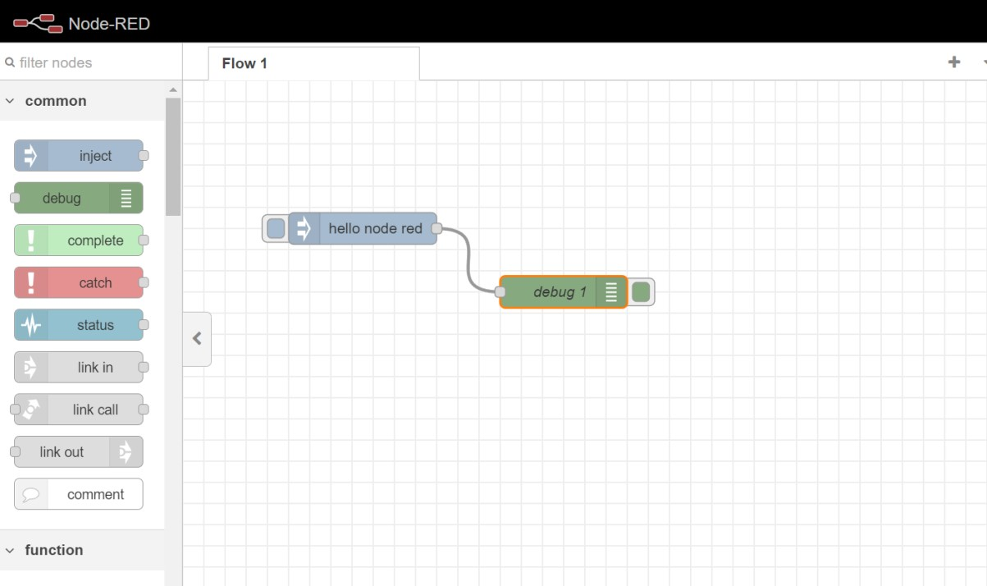

Output :

